Question bank on Module 2
 | Permutation without repetition
1) | How many different 4-digit numbers can be formed using 1, 2, 3, 4, 5, 6 without repetition? | (2.5)
2) | From 8 students, in how many ways can 3 students be selected and arranged for the positions of President, Secretary and Treasurer? | (2.5)
3) | A company has 7 employees. In how many ways can it assign Manager, Team Leader and Developer positions to different employees? | (2.5)
4) | A company has 6 servers and wants to assign three different roles: Web server, Database server and Backup server. Each role must be assigned to a different server. In how many ways can the roles be assigned? | (2.5)
5) | A network engineer has 5 different routers available. Three routers need to be selected and arranged in a specific order for a test network. How many possible arrangements are there? | (2.5)
6) | In how many ways can 7 people be arranged if two particular people must always be together? | (2.5)
 | Permutation with repetition
7) | How many 3-digit numbers can be formed using the digits 2, 3, 4, 5 and 6 if repetition is allowed? | (2.5)
8) | How many 4-digit PINs can be made using digits 0 through 9 if numbers can repeat? | (2.5)
9) | Find how many ways you can rearrange letters of the word “BANANA” all at a time. | (2.5)
10) | Find the number of arrangements of the word BALLOON. | (2.5)
 | Combination without repetition
11) | A class has 5 students. We need to select a team of 2 students for a project. | (2.5)
12) | Find the number of ways to select 3 books from 5 different books on the shelf. | (2.5)
13) | Rahul has to choose 5 marbles from 12 different colored marbles. In how many ways can she choose them? | (2.5)
14) | Jayesh asks his daughter to choose 4 pens from the basket. If the basket has 18 different pens to choose from, how many different possible ways she can do it? | (2.5)
15) | You want to pick 2 different toppings for a pizza from a menu of 5 choices. In how many ways, it can be done? | (2.5)
16) | How many ways can you draw a hand of 5 cards from a standard deck of 52 cards? | (2.5)
17) | Suppose you have the digits: 1, 2, 3, 4, 5, 6. In how many ways any 3 digits can be selected without repetition? | (2.5)
18) | How many bit strings of length 6 contain exactly four 1s? | (2.5)
19) | How many bit strings of length 8 contain exactly two 1s? | (2.5)
20) | A binary message consists of 10 bits. Exactly 4 bits must be 1 and the remaining 6 bits must be 0. How many different messages are possible? | (2.5)
 | Combination with repetition
21) | A shop has 3 types of fruits: Apple, Banana and Orange. You want to select 4 fruits, and you can select the same fruit more than once. In how many ways you can select? | (2.5)
22) | There are 4 flavours of ice cream. A customer wants 3 scoops, and the same flavour can be selected more than once. How many different ways are possible? | (2.5)
23) | A bit string contains 0s and 1s. How many ways can we select 5 bits if repetition is allowed and order is ignored? | (2.5)
24) | You are ordering a bowl with 4 scoops of ice cream, and there are 5 different flavors available (Chocolate, Vanilla, Strawberry, Mint, and Mango). You are allowed to repeat flavors and the order of scoops doesn't matter. How many different ice cream combinations can you make? | (2.5)
25) | A bakery sells 3 types of donuts: Glazed, Chocolate, and Jelly. In how many ways can you choose a box of 6 donuts if repetition of types is allowed and the order in which they are placed in the box doesn't matter? | (2.5)
 | De Morgan’s laws
1) | State and prove De Morgan’s laws of sets using Venn diagram. | (5)
2) | Let the Universal set U = {1, 2, 3, 4, 5, 6, 7}, A = {1, 2, 3, 4} and B = {3, 4, 5, 6}. Find  a) A $∪$ B  b) (A $∪$ B)’  c) A’  d) B’  e) A’ $∩$ B’ | (5)
3) | Let U = {a, b, c, d, e, f}, A = {a, b, c} and B = {b, c, d}. Find  a) (A $∪$ B)’  b) (A $∩$ B)’  c) A’ $∩$ B’  d) A’ $∪$ B’ | (5)
4) | Let U = {0, 1, 2, 3, 4, 5}, A = {0, 1, 3} and B = {1, 2, 4}. Find  a) (A $∪$ B)’  b) (A $∩$ B)’  c) A’ $∩$ B’  d) A’ $∪$ B’ | (5)
5) | Let U be the set of all positive integers.  A = {x : x is even}  B = {x : x is a multiple of 3}  a) (A $∪$ B)’  b) (A $∩$ B)’ | (5)
6) | In a class of 40 students, A is the set of students who play cricket and B is the set of students who play football. Express the set of students who play neither cricket nor football using De Morgan’s laws and represent this area by shaded region using Venn diagram. | (2.5)
7) | In a group of 50 people, A represents people who like coffee and B represents people who like tea. Express the set of people who do not like both coffee and tea using De Morgan’s law and represent it by a shaded region using Venn diagram. | (2.5)
8) | Let A be the set of computers with antivirus software and B the set of computers with a firewall. Express the set of computers having neither antivirus nor a firewall using De Morgan's law and represent it by a shaded region using Venn diagram. | (2.5)
 | Function and its types
1) | Let X = {2, 4, 5} and Y = {1, 2, 4, 6}. Determine which of the following arrow diagrams determine functions from X to Y? Explain with reason which diagram does not represent a function.  a) 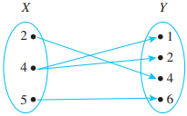  b) 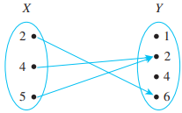 | (5)
2) | Let X = {2, 4, 5} and Y = {1, 2, 4, 6}. Determine which of the following arrow diagrams determine functions from X to Y? Explain with reason which diagram does not represent a function.  a) 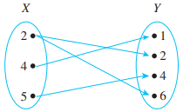  b) 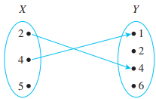 | (5)
3) | Let A = {1, 2, 3} and B = {x, y, z}. The function $f:A→B$ is defined as f(1) = x, f(2) = y and f(3) = z. Determine the type of function by using an arrow diagram. | (2.5)
4) | Let A = {1, 2, 3} and B = {x, y, z, w}. The function $f:A→B$ is defined as f(1) = x, f(2) = y and f(3) = z. Determine the type of function by using an arrow diagram. | (2.5)
5) | Let A = {1, 2, 3, 4} and B = {x, y, z}. The function $f:A→B$ is defined as f(1) = x, f(2) = y, f(3) = z and f(4) = y. Determine the type of function by using an arrow diagram. | (2.5)
6) | Let A = {1, 2} and B = {x, y, z}. The function $f:A→B$ is defined as f(1) = x, f(2) = x. Determine the type of function by using an arrow diagram. | (2.5)
7) | Determine the type of function represented by an arrow diagram with reason.  a) 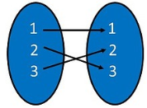 b) 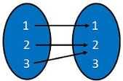 | (5)
8) | Determine the type of function represented by an arrow diagram with reason.  a) 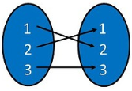 b) 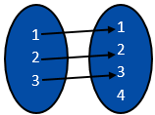 | (5)
9) | Determine the type of function represented by an arrow diagram with reason.  a) 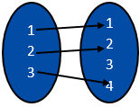 b) 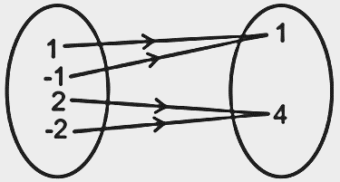 | (5)
10) | Determine the type of function represented by an arrow diagram with reason.  a) 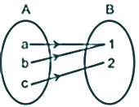 b) 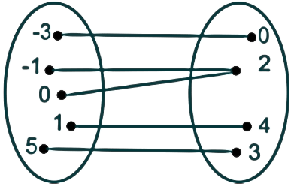 | (5)
11) | Determine the Domain, Co-domain and Range of the functions represented by following arrow diagram.  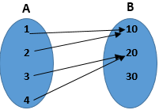 | (5)
12) | Determine the Domain, Co-domain and Range of the functions represented by following arrow diagram.  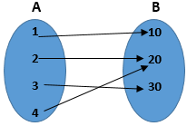 | (5)
13) | Determine the Domain, Co-domain and Range of the functions represented by following arrow diagram.  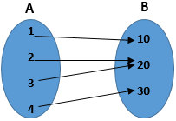 | (5)
14) | Determine the Domain, Co-domain and Range of the functions represented by following arrow diagram. | (5)
15) | Determine the Domain, Co-domain and Range of the functions represented by following arrow diagram. | (5)

